

AMITY INSTITUTE OF INFORMATION TECHNOLOGY

Course Code : CSE1023

“WEB PROGRAMMING”

LABORATORY RECORD

Summer Semester - 2025

SUBMITTED TO:
Ms. Neethu Tressa
SUBMITTED BY:
ANANYA B
A86904824021
BCA

INDEX
Sl. No. | Date | Program | Page No.
1 |  | Create a basic HTML document
2 |  | Insert images and link pages
3 |  | Design a basic HTML table
4 |  | Format text using HTML formatting tags
5 |  | Create ordered, unordered, and detialed lists
6 |  | Create an HTML form
7 |  | Embed audio and video files into a web page
8 |  | Use semantic elements in a layout
9 |  | Use common semantic tags
10 |  | Apply Inline, Internal, and External CSS
11 |  | Create a layout using <div> and <span>
12 |  | Demonstrate cascading order and multiple CSS files
13 |  | Use various CSS selectors
14 |  | Style a page with fonts, colors, and text properties
15 |  | Explore the CSS Box Model
16 |  | Display output and debug using JavaScript
17 |  | Use variables, operators, and data types
18 |  | Create and manipulate arrays and strings
19 |  | Form validation using JavaScript
Program 1
Title: Create a basic HTML document
Aim: Use document structure, headings, paragraphs, <hr>, <br>, and &nbsp.

my1.html
<html>
<head>
<title>Basic HTML</title>
</head>
<body>
<h1>Hello!</h1>
<p>This is a basic paragraph.Welcome to HTML.</p>
<hr>
<h2>Things I Like</h2>
<p>• Music<br>• Games<br>• Travel</p>
</body>
</html>
Web Page
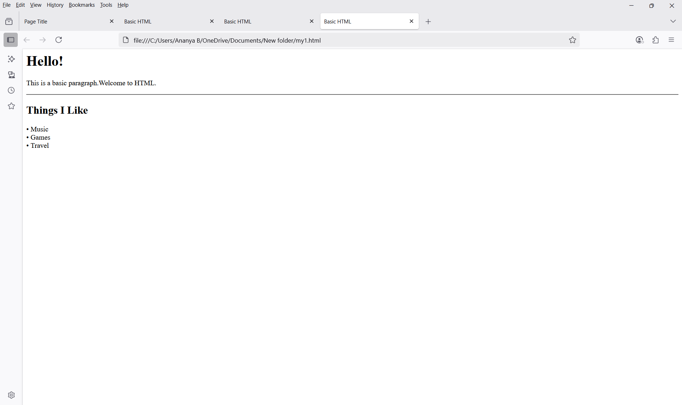

Program 2
Title: Insert images and link pages
Aim: Embed images using <img> and link to another page using <a>.

my2.html
<html>
<head>
<title> Page Title </title>
</head>
<body>
<h2> This is a heading </h2>
<p> This is a paragraph </p>
<p> This is another paragraph </p>
<img src="rose.png" alt="This is a rose" width="200" height="300">
<a href="https://www.google.com"> Go to Google </a>
</body>
</html>
Web Page
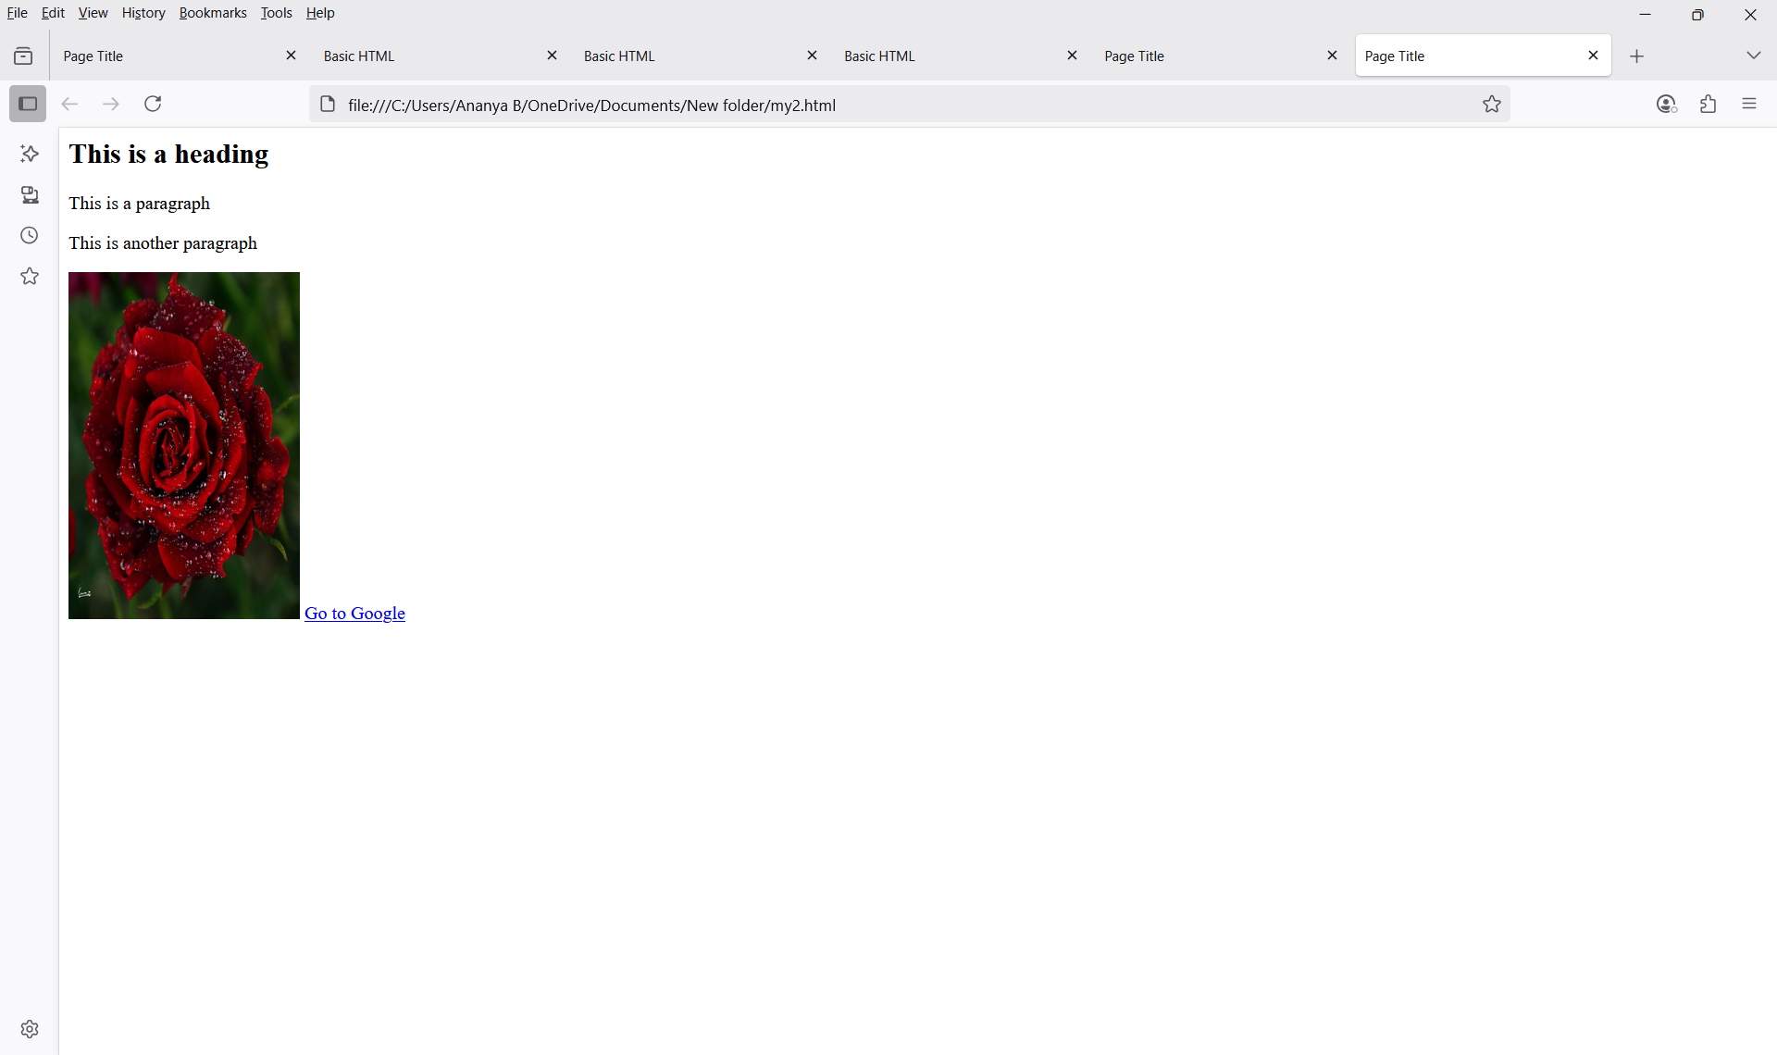

Program 3
Title: Design a basic HTML table
Aim: Use <table> and apply rowspan and colspan
Htmlassignment5.html
<html>
<head>
<title>table creation</title>
</head>
<body>
<table border="1">
<tr>
<th rowspan="2">HEADING</th>
<th>STUDENTS</th>
<th colspan="3">DETAILS</th>
</tr>
<tr>
<th>ID</th>
<th>NAME</th>
<th>DEPARTMENT</th>
<th>ROLL NUMBER</th>
</tr>
<tr>
<th rowspan="4">STUDENT LIST</th>
<td>1</td>
<td>Victor</td>
<td>Computer science</td>
<td>12345</td>
</tr>
<tr>
<td>2</td>
<td>Williams</td>
<td>Electronics</td>
<td>23456</td>
</tr>
<tr>
<td>3</td>
<td>Harry</td>
<td>Electronical</td>
<td>34567</td>
</tr>
<tr>
<td>2</td>
<td>Rick</td>
<td>Civil</td>
<td>45678</td>
</tr>
</table>
</body>
</html>
Web Page
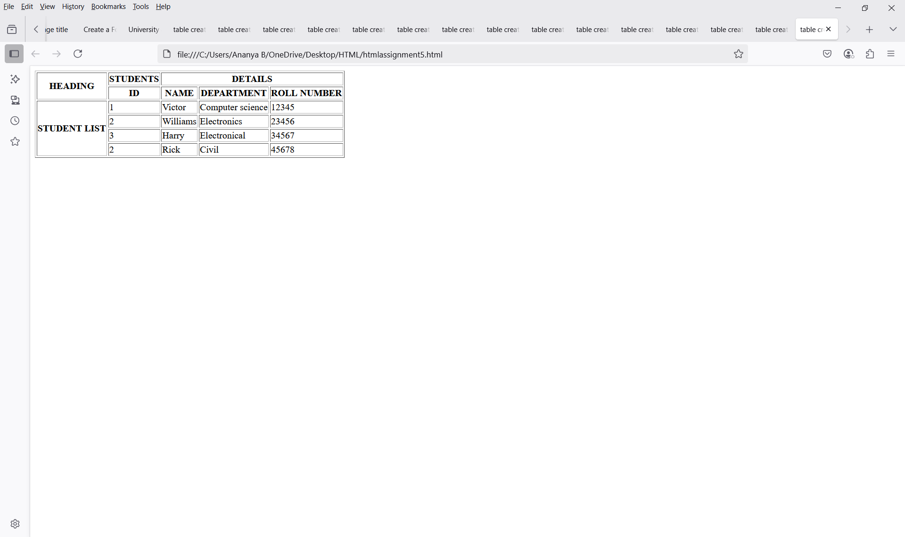

Program 4
Title: Format text using HTML formatting tags
Aim: Use <b>, <i>, <u>, <mark>, <sup>, <sub>, etc.

ananya12.html
<html>
<head>
<title>create a formatting paragraph</title>
</head>
<body>
<p><b>My father is the most beloved person in my family, and he loves me the most.</b></p>
<p><strong>He is the one who fulfils our needs and wishes without any complaint.</strong></p>
<p><i>My father always believes me and shows a sense of confidence in me.</i></p>
<p><em> Whenever I feel depressed or sad, he is the one who motivates me with his words.</em></p>
<p><mark> His love for us and other family members is selfless and unconditional.</mark></p>
<p><small> He is the one on whom the whole family can trust.</small></p>
<p>He becomes angry whenever we do not follow the discipline <del> and manners </del>of the house.</p>
<p> He always motivates us to do <ins>well in exams and also helps in our studies.</ins></p>
<p>He solves all our issues happily but<sub> never lets his problems come to us.</sub></p>
<p> My father is my hero and will always be <sup>my guiding soul and motivator for life.</sup></p>
<p> My father is <u>my best friend</u>, and I can share each and everything with him.</p>
</body>
</html>
Web Page
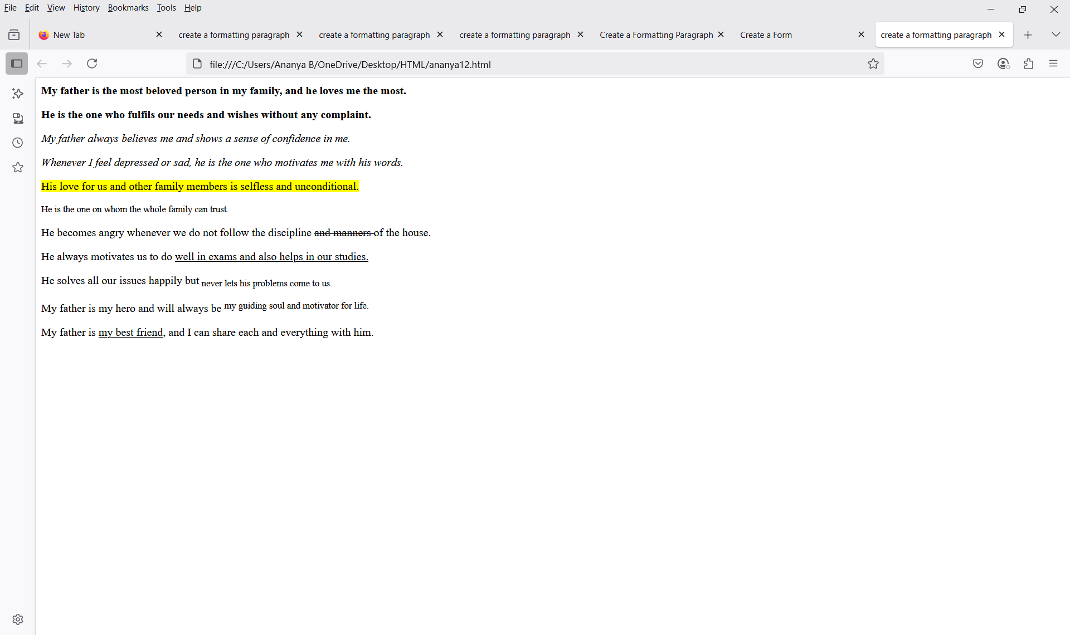
Program 5
Title: Create ordered, unordered, and detialed lists
Aim: Demonstrate different list types

ananya16.html
<html>
<head>
<title>lists</title>
</head>
<body>
<h2>An unordered HTML list</h2>
<ul>
<li>coffee</li>
<li>tea</li>
<li>milk</li>
</ul>
<h2>An ordered HTML list</h2>
<ol>
<li>coffee</li>
<li>tea</li>
<li>milk</li>
</ol>
<h2>A Description list</h2>
<dl>
<dt>coffee</dt>
<dd>black hot drink</dd>
<dt>tea</dt>
<dd>white cold drink</dd>
</dl>
</body>
</html>

Web Page

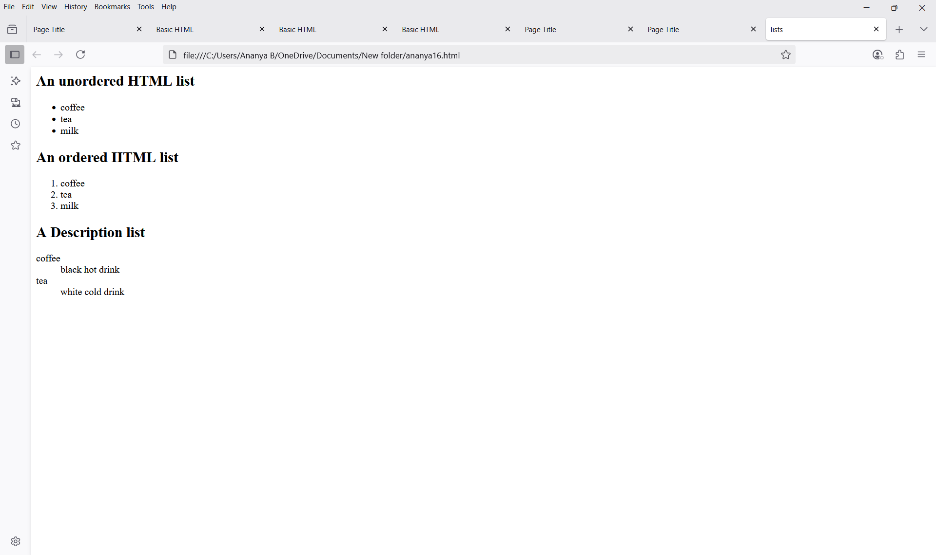

Program 6
Title: Create an HTML form
Aim: Include input types like text, radio, checkbox, textarea, button, and select.

ananyaassignment.html
<html>
<head>
<title>University admission form</title>
</head>
<form>
<label>FULL NAME:</label>
<input type="text" name="full name"><br><br>
<label for="dob">Date of Birth:</label>
<input type="date" id="dob" name="dob"><br><br>
<label>Gender:</label><br>
<input type="radio" id="male" name="gender" value="male">
<laSCbel for="male">Male</label>
<input type="radio" id="female" name="gender" value="female">
<label for="female">Female</label>
<input type="radio" id="others" name="gender" value="others">
<label for="others">Others</label><br><br>
<label for="course applied for">course applied for:</label><br>
<select id="course applied for" name="course applied for">
<option value="B.Sc">B.Sc</option>
<option value="B.A">B.A</option>
<option value="B.Com">B.Com</option>
<option value="B.Tech">B.Tech</option>
<option value="M.Sc">M.Sc</option>
<option value="M.A">M.A</option>
</select><br><br>
<label>Email:</label>
<input type="email" name="email"><br><br>
<label for="phone">phone number:</label>
<input type="tel" id="phone" name="phone"><br><br>
<label for="Address">Address:</label><br>
<textarea id="Address" name="Address" rows="4" cols="40"></textarea><br><br>
<label for="percentage">12th Grade Percentage:</label>
<input type="number" id="percentage" name="percentage" min="0" max="100"><br><br>
<label for="upload 12th markssheet">upload 12th markssheet:</label><br>
<input type="file" id="upload 12th markssheet" name="upload 12th markssheet"><br><br>
<label>SELECT SUBJECTS:</label><br>
<input type="checkbox" name="subjects" value="physics">physics
<input type="checkbox" name="subjects" value="chemistry">chemistry
<input type="checkbox" name="subjects" value="maths">maths
<input type="checkbox" name="subjects" value="biology">biology
<input type="checkbox" name="subjects" value="computer science">
<input type="checkbox" name="subjects" value="economics"><br><br>
<label>Preferred Mode of Admission:</label><br>
<label>
<input type="radio" name="admission_mode" value="merit"> Merit
</label><br>
<label>
<input type="radio" name="admission_mode" value="entrance"> Entrance Exam
</label>
</form>
</html>

Web Page

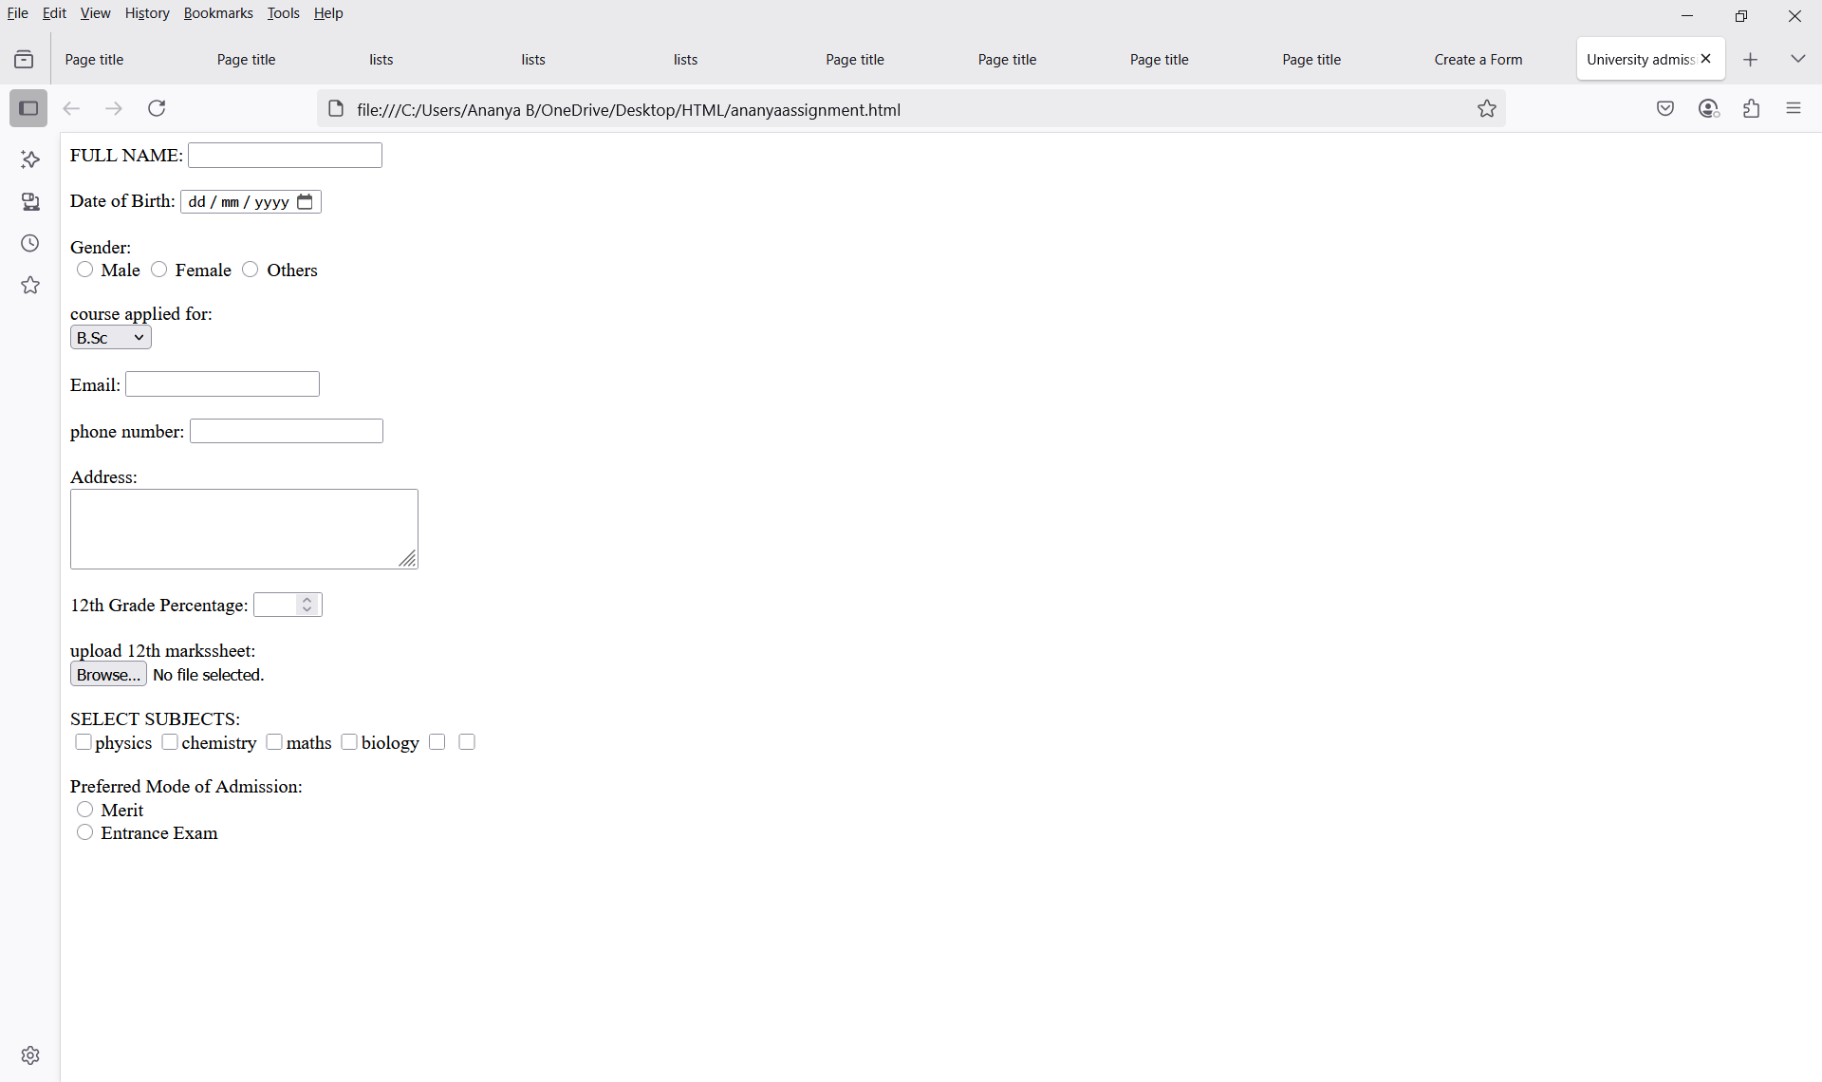

Program 7
Title: Embed audio and video files into a web page
Aim: Use <audio> and <video> tags with controls.

ananya17.html
<html>
<head>
<title>adding audio</title>
</head>
<body>
<audio controls>
<source src="sample-15s (1).mp3" type="audio/mpeg">
Your browser does not support the audio element.
</audio><br><br>
<video width="400" controls>
<source src="sample-mp4-files-sample_640x360 (2).mp4" type="video/mp4">
your browser does not support thye video tag.
</video>
</body>
</html>

Web Page
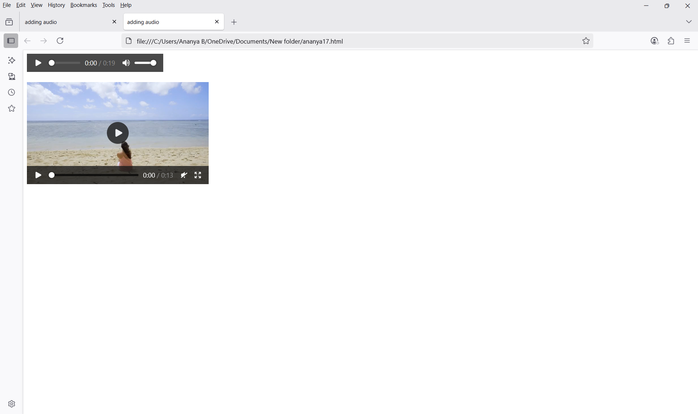
Program 8
Title: Use semantic elements in a layout
Aim: Structure a page using <header>, <nav>, <main>, <section>, <article>, <aside>, <footer>.

ananya18.html
<html>
<head>
<title>Semantic Page</title>
</head>
<body>
<header>
<h1>My Website</h1>
</header>
<nav>
<a href="#">Home</a> |
<a href="#">About</a> |
<a href="#">Contact</a>
</nav>
<main>
<section>
<h2>Welcome</h2>
<p>This is the main content.</p>
</section>
<article>
<h3>Article Title</h3>
<p>This is an article.</p>
</article>
<aside>
<p>This is a sidebar with extra info.</p>
</aside>
</main>
<footer>
<p>© 2025 My Website</p>
</footer>
</body>
</html>

Web Page

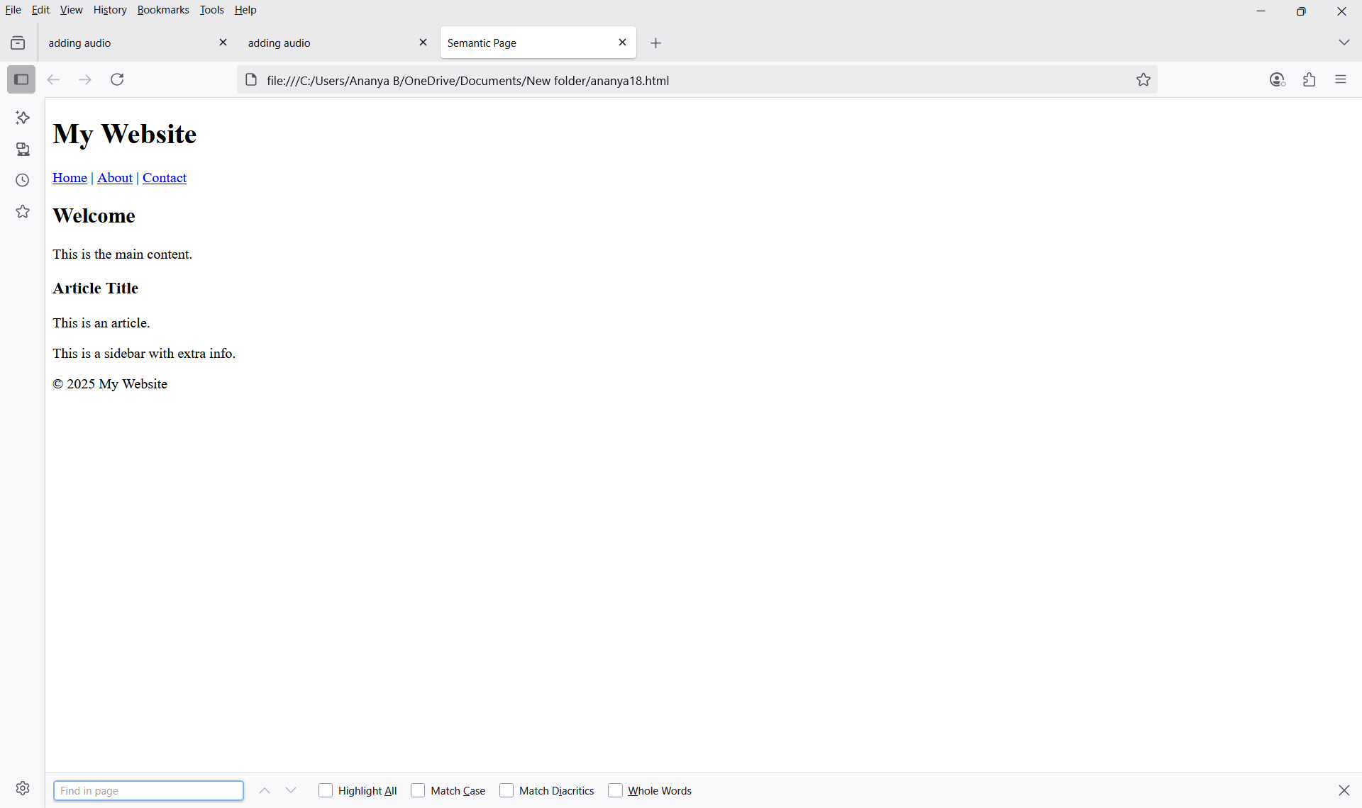

Program 9
Title: Use common semantic tags
Aim Experiment with <details>, <summary>, <figcaption>, <figure>, <blockquote>, <abbr>, <address>, <bdo>, <cite>, <q>.

ananya20.html
<html>
<head>
<title>Semantic Tags</title>
</head>
<body>
<h1>Semantic Tags Example</h1>
<details>
<summary>More Info</summary>
<p>This is extra information.</p>
</details>
<figure>
<img src="image.png" alt="Image" width="100" height="100">
<figcaption>Sample image</figcaption>
</figure>
<blockquote>Life is beautiful.</blockquote>
<p> <abbr title="HyperText Markup Language">HTML</abbr> is used to create webpages.</p>
<address>
apparreal,bangalore<br>
Email: appy@example.com
</address>
<p>
Normal: Hello<br>
<bdo dir="rtl">Hello</bdo>
</p>
<p>He said <q>I love coding</q>. </p>
<p>
<cite>The Ramayana</cite> is an ancient Indian epic.
</p>
</body>
</html>

Web Page

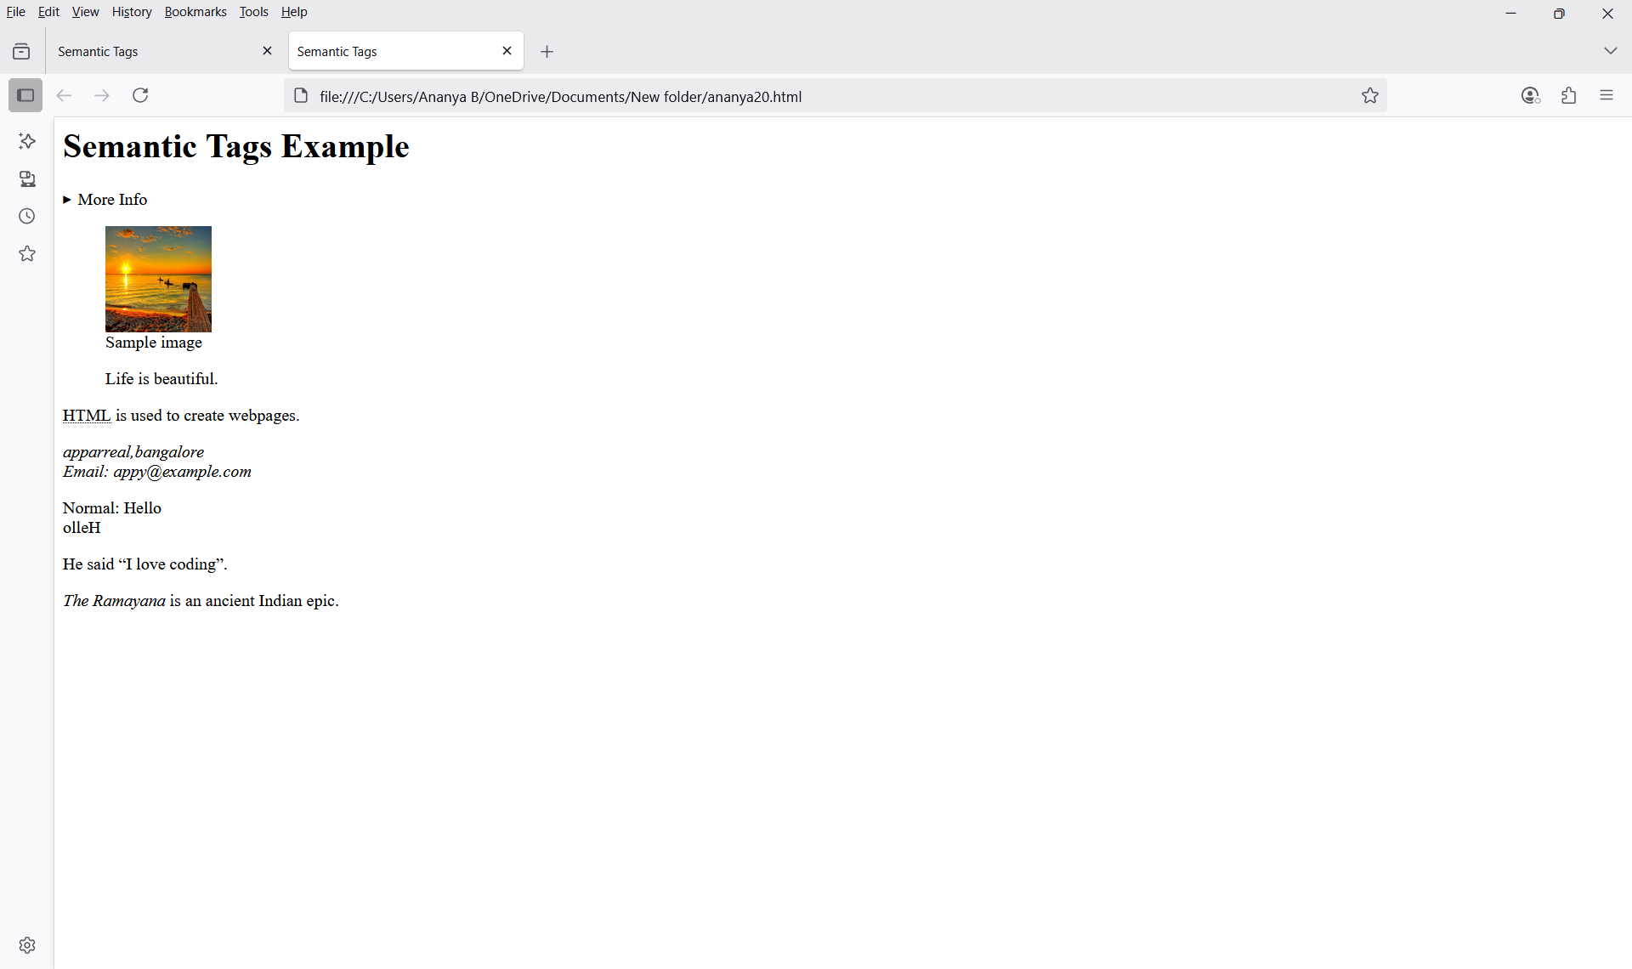

Program 13
Title: Use various CSS selectors
Aim: Demonstrate Element, ID, Class, Universal, and Grouping selectors.

ananya21.html
<html>
<head>
<title>Element, ID, Class</title>
<style>
p {
color: blue;
text-align: center;
}
#para1 {
text-align: center;
color: orange;
}
.center {
text-align: center;
color: pink;
}
</style>
</head>
<body>
<p>This is a normal paragraph.</p>
<p id="para1">This paragraph has an ID.</p>
<p class="center">This paragraph has a class.</p>
</body>
</html>

Web Page
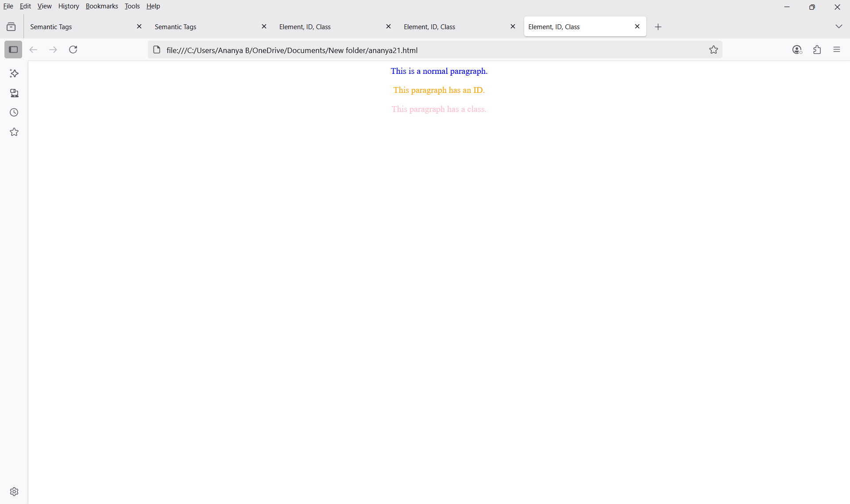

ananya22.html
<html>
<head>
<title>Universal Selector</title>
<style>
* {
text-align: center;
color: orange;
}
</style>
</head>
<body>
<h1>All elements have same style</h1>
<p>This is a paragraph.</p>
</body>
</html>

Web Page
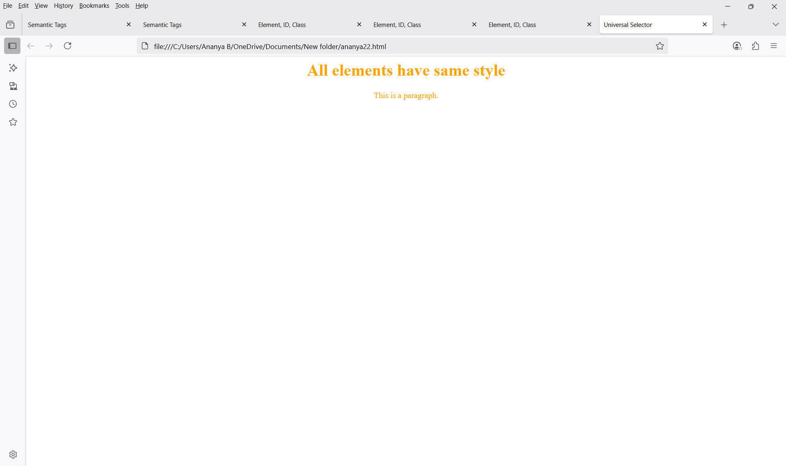

ananya23.html
<html>
<head>
<title>Grouping Selector</title>
<style>
h1, p {
color: green;
text-align: center;
}
</style>
</head>
<body>
<h1>This is a heading</h1>
<p>This is a paragraph</p>

</body>
</html>

Web Page
